1. Install Node <https://nodejs.org/en/download/> (Recommended for Most Users version)
2. Make git clone https://github.com/luferau/VisaWebClient.git

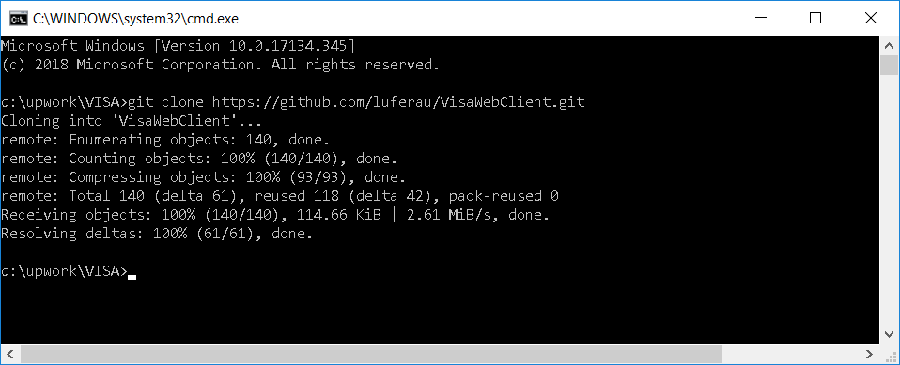

1. VS Code File – Open folder

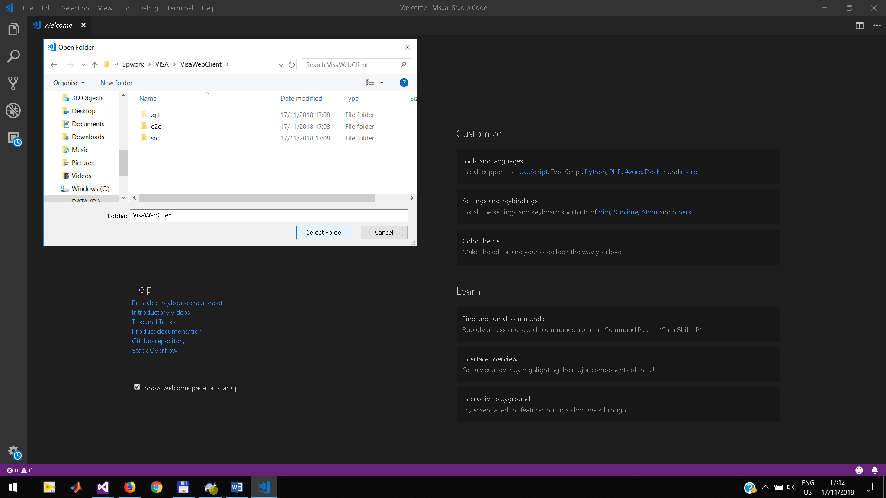

1. Terminal – New terminal Ctrl+Shift+~

Run npm install -g @angular/cli

Run npm install

1. Run ng serve

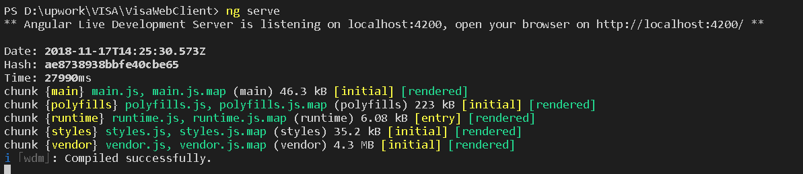

1. Open <http://localhost:4200> in browser